Role Title | Remote Engineering and Compliance Auditor
Reports to | Head of Transport UK Rail Replacement & Taxis
Division/Department | Business support
Location | Reginal
Grade

Purpose of Role
Assessing the engineering and operational processes, systems, and procedures of suppliers to ensure they meet the required standards and regulations. The role is crucial in maintaining safety, quality, and performance of our rail replacement pool of suppliers.

By conducting audits, the auditor evaluates the supplier's compliance with technical and safety standards, reviews maintenance records, inspects safety protocols, and assesses engineering specifications. The auditor shall provide detailed reports to document and communicate findings and outcomes.

The remote aspect of the role allows when appropriate, the auditor to efficiently collaborate with suppliers using advanced auditing technologies. However, on-site audits are necessary to suitably understand and review our suppliers’ capabilities.

The purpose of the auditor is to ensure that our suppliers adhere to industry-specific regulations, best practices & Transport UK Rail Replacement definite requirements, enhancing the reliability and efficiency of our Rail Replacement services.

As an auditor the role dimensions are to verify compliance, identify areas for improvement, and provide recommendations for corrective actions.

Overall, the remote supplier engineering auditor plays a vital role in maintaining the highest level of safety, engineering excellence, regulatory compliance, and operational performance among our suppliers. This ensures the provision of safe and reliable transportation services for our passengers.

Key Accountabilities
- Conduct remote and on-site of our suppliers of bus and coach operators to assess their engineering and operational processes, systems, and procedures.
- Evaluate supplier compliance with relevant regulations, industry standards, and company requirements.
- Review/ analyse technical documents, such maintenance records, safety & training records & specific bus and coach & HGV compliant records, Tacho `s, OCR reports ect .
- Collaborate with internal stakeholders & reginal management to ensure alignment on audit objectives, findings onboarding/off boarding of suppliers.
- Prepare & manage detailed audit reports both internally & externally, documenting findings, observations & recommendations for corrective actions.
- Maintain accurate and up-to-date records of audits conducted, including documentation of follow-up actions taken by suppliers.
Role Dimensions
On site and Remote Auditing, Travel required and over night stays necessary
Assessing the engineering processes & working practices of Transport UK RR supplier pool
Compliance Verification to ensure Safety and Performance Enhancement of RR services
Reporting and Recommendations externally to suppliers and internally back to the business

Main Contacts
Contacts | Frequency | Purpose
Reginal Management | Daily/weekly | Ensure Operational safety and performance
Line management | Weekly | Objectives and review
Senior management | Monthly | KPI presentation

Person Specification
Attainments: education, qualifications & training requirements | - Experience in conducting remote audits or inspections within the transport industry specifically bus and coach.  - Strong knowledge of engineering and operational principles, regulations, and best practices related to bus and coach operations.  - Professional certification or accreditation in auditing, such as Certified Quality Auditor (CQA) or Certified Internal Auditor (CIA).  - Familiarity with relevant industry standards and regulations, such as ISO 9001, ISO 14001, or specific transportation safety standards.  - Transport managers CPC (PCV) qualification  IRTEC accreditation. Vehicle inspection or maintenance or equivalent.
Abilities:  skills & aptitudes required. | - Ability to work independently and remotely, managing multiple audits simultaneously.  - Excellent communication skills, both written and verbal, to effectively convey audit findings and recommendations internally & externally.  - Strong analytical skills are crucial to be able to assess complex information, identify patterns, and draw logical conclusions.  - Proficient in using remote collaboration tools and software for conducting audits.  - Fully IT literate in MS suite Excell, Power, Point  - Ability to prioritise workload based on risk and business need.
General intelligence: experience & knowledge capabilities | - Detail-oriented with exceptional organizational and documentation skills.  - Excellent analytical and problem-solving skills, with the ability to identify areas for improvement and recommend effective solutions.  - A strong geographical knowledge of the region(s) you are assigned.  - Strong interpersonal skills & ability to put suppliers at ease during audits.  - Must have a high level of integrity and ethical standards, honest, unbiased, and independent in their assessments to ensure the accuracy and reliability of findings.
Personal circumstances/ requirements: | - Ability to work independently and remotely, managing multiple audits simultaneously.  - Valid driver's license and ability to operate a vehicle safely when working.  - Ability to travel and when required work with overnight stays.  - Have a good & stable home working environment & internet connection to conduct work activities.

Transport UK Values
At Transport UK Rail Replacement, we share a set of common principles and processes with the wider Transport UK group known as the TUK Way. This strategic framework supports the achievement of our goal of becoming ‘the best bus company in London and is underpinned by our organisational values. It is expected that all colleagues demonstrate these behaviours in their work.

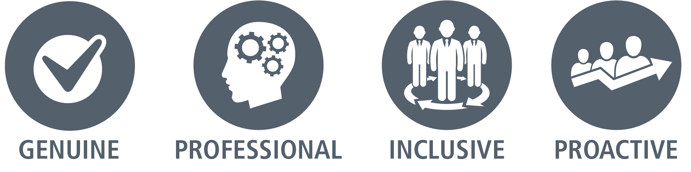 | We’re respectful, straightforward, customer centric, open, and welcoming.
 | We take our responsibilities seriously; we take ownership and are accountable. We also deliver on our promises, are responsive and cost-conscious.
 | We passionately believe in diversity and ensure we work in a way that’s inclusive, connected with our stakeholders and promoting empowerment.
 | We’re progressive, forward-thinking, innovative and decisive. We focus on continuous improvement and challenging the status quo.

