Job Title: Train Presentation Operative
Job Description

Location Worcester Depot

Responsible to: Train Presentation Supervisor

Safety Status: Non - Safety Critical

Hours of Duty: 45 Hours
Shift work

Description
We are currently recruiting for a full time Train Presentation Operative (TPO) for Carriage Cleaning at our Worcester Depot.
In this role you will be working 45 hours per week (permanent night shifts) to work independently or in a group in order to carry out the cleaning of our trains. This is a vital role to ensure our train environment is to the correct standard required by our customers. Duties will include carrying out designated cleaning duties in accordance with cleaning procedures and ensuring compliance and procedures are upheld.
Duties include
  - Use of specialist cleaning chemicals and equipment
  - Take responsibility for Materials and equipment provided to carry out tasks required
  - Undertake controlled emission toilet (CET) and extractions and when required.
  - Complete audit sheets as required and report non-conformances to Train Presentation Supervisor.
  - Disposal of rubbish removed from trains in the appropriate location
  - Remove full bin liners and re-line on train bins when found full or nearly full
  - Fit seat reservation labels where required by local arrangements
The successful candidate will possess:
  - Excellent customer service skills
  - Excellent attention to detail and pride in work
  - Customer focused
  - Able to work on own initiative
  - Good communication skills, written and oral
  - Organised
  - Attention to detail
  - Able to work to tight deadlines
  - High standards of work
  - Able to work shifts
Applications will be considered from colleagues with 6 months experience after completion of their probationary period and a full check of absence and disciplinary records. ​
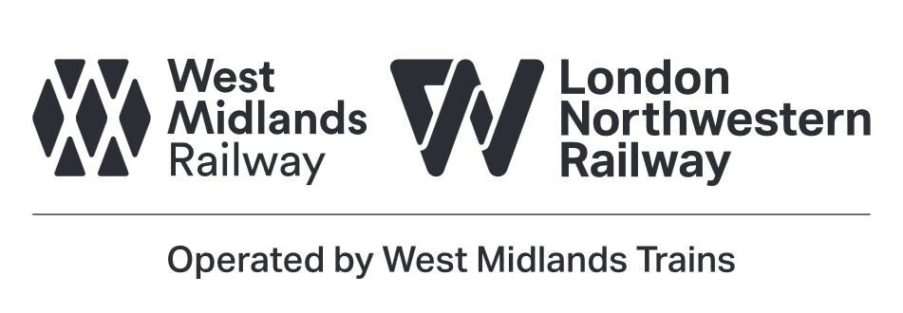

Name of job holder:

Signature of job holder:

Date job holder signed:

Signature of job holder’s immediate line manager:
SM/CC AUG 18

