Job Title: Train Care Supervisor

Location Various

Responsible to: Area Train Presentation Manager
Grade Supervisor Grade CSSA A

Safety Status: Non - Safety Critical

Hours of Duty: 37 Hours

Shift patterns

Sundays as agreed

Purpose of the job
Lead and direct cleaning staff to enable the cleaning of traction and rolling stock at locations in designated areas in a safe and efficient manner, to laid down VCI standards.

Duties
- Oversee all aspects of the cleaning of trains in traffic, to include acting as the contact point for West Midlands Trains Control with regard to biohazards and to ensure they are dealt with correctly.
- Leading staff to ensure the prompt cleaning of traction and rolling stock in traffic, in accordance with laid down regulations and specifications.
- To ensure that work is carried out in an efficient manner on an economical basis, and that matters of an urgent nature are given the correct priority.
- Inspection of work carried out by staff to include in-process inspections and audits.
- Report and make recommendations regarding staff levels and working arrangements.
- Take ownership for quality and safety processes and procedures ensuring upkeep of cleanliness, safety precautions, accident prevention and reporting, in accordance with procedures and regulations. Ensure Health and Safety at Work requirements are being met by carrying out site inspection, audits and in process inspections as required.
- Liaise with other departments and technical staff by attending meetings as required by the Area Train Presentation Manager.
- Formulate and produce staff rosters and diagrams on a weekly basis (and during timetable change) and authorise any changes on a daily basis as required.
- Sign off staff booking on/off times.
- Confirm accuracy, authorise and transmit timesheets to Payroll.
- Carry out MFA 1 interviews as required.
- Undertake responsibilities under local quality/safety systems and take ownership of procedures that relate to on train cleaning.
- Ensure compliance with processes and procedures in respect of the Environmental Management system to ISO14001.
- Forecast and plan material requirements for on train cleaning. Identify surplus/obsolete materials and arrange disposal from the depot in conjunction with the management at Soho.
- To act as the first line of contact for on train cleaning staff.
- Maintain good industrial relations within area of responsibility.
- Lead actions that improve cleaning and action any non-conformance.

Person Specification

- Attention to detail.
- High standard of personal presentation and professionalism.
- Able to work to the highest standards setting the example to staff.
- Excellent interpersonal skills and an efficient decision maker.
- Positive attitude.
- High standard of honesty and integrity.
- Willingness to work unsociable hours.
- Acceptable standards of English, Maths and general administration.
- Able to remain calm under pressure.
- Able to organise own working time to maximum potential.
- Friendly, open approach and proactive when dealing with customer requirements.
- Willingness to undergo personal development attending training courses as necessary.
- Ability to learn legislation that relates to role.
- Flexible and willing to adapt to agreed changes.

Name of job holder:

Signature of job holder:

Date job holder signed:

Signature of job holder’s immediate line manager:

Signature of Departmental Director___________________________________

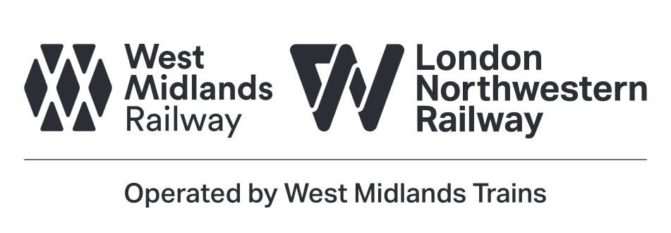
HR/CC July 2017

