Job Description

Job Holder: Marketing Manager, West Midlands Railway

Reports to: Head of Sales & Marketing

Grade:

Safety Status: NSC

Date version agreed: Draft Version One

1. Job Purpose

1.1 West Midlands Railway is a new brand with transformational plans to change the way people travel into Birmingham and around the West Midlands. This job is to bring the brand to life through campaigns focussed on maximising the investment opportunities to drive profitable growth, whilst building trust amongst users and non-users.

2. Key Accountabilities

2.1 Plan marketing communication campaigns utilising the full marketing mix, to deliver activity to target customer segments including business, leisure, commuter & airport travel.

2.2 Maximise the planned investment opportunities eg. new trains, improved timetables, new stations etc, and take advantage of latent demand to drive growth.

2.3 Own and deliver the annual marketing calendar, taking into account positive and negative exogenous factors that impact usage eg. seasonality, improvement upgrade work, events etc.

2.4 Work closely with the marketing team, revenue management, sales, customer experience and retail functions to understand and develop customer propositions to drive trust and revenue.

2.5 Work closely with digital in-house and communications expertise to enhance propositions through online, PR and own channels to drive conversion, awareness and trust.

2.6 Partner with event, attraction and tourism agencies (eg. Marketing Birmingham) to deliver joint activity for commercial benefit.

2.7 Manage strategic stakeholder expectations, in-line with business requirements eg.Transport for West Midlands, Community Rail Partnerships, West Midlands Growth Company.

2.8 Work closely with revenue management and brand tracking & econometrics agencies to ascertain revenue and trust impact of activity. Use findings and predictions to optimise future activity.

2.9 Brief and manage agencies to deliver (but not limited to) advertising, consumer PR and social campaigns. Lead new agencies pitches.

2.10 Contribute to the development of marketing propositions to support the new product, route and service initiatives

2.11 Brand guardian of West Midlands Railway.

2.12 Foster a proactive, positive culture.

3. | Role Dimensions
Financial |  |  | Non-Financial
WMR advertising budget – circa £700k |  |  | Understanding all elements of the marketing mix
WMT revenue targets £460m |  |  | Proactively manage self-development and being a positive voice for WMT inside and outside of the industry.
4. | Main Contacts (External/Internal) *
Contacts |  | Frequency |  | Purpose
WMT Head of Sales & Marketing |  | Daily, weekly, monthly |  | Objectives and plans briefing and activity progress and result reports.
WMT marketing team |  | Daily, weekly, monthly |  | Collaboration & briefing activity plans, measurements and results.
Customer Service Director (and/or team) |  | Monthly, as required |  | Understand operational challenges from a customer perspective. Support enhancement of local exposure.
WMT Market Analyst (revenue) and Customer Insights Manager (customer experience) |  | Daily, weekly, monthly |  | Insights and targeting
Suppliers: advertising, social, consumer PR, media |  | Daily, weekly, monthly |  | Briefing, planning, buying, delivery
Abellio Group / sister TOCs |  | As required |  | Share knowledge & collaborate on projects
Strategic stakeholders & marketing partnerships |  | As required |  | Share & support versus the business requirements

5. | Experience, Knowledge & Qualifications Required
5.1 | Educated to degree level, ideally with marketing qualifications
5.2 | Minimum 3-year experience in a senior marketing planning or product role
5.4 | Logical thinker with excellent organisational and project management skills. Proven track record of budget management and working with a new brand.
5.5 | Ability to multi-task and deliver under tight deadlines
5.6 | Commercially minded approach, turn findings into actions
5.7 | Excellent negotiation and communication skills
5.9 | Creative thinker

7. Organisation Chart

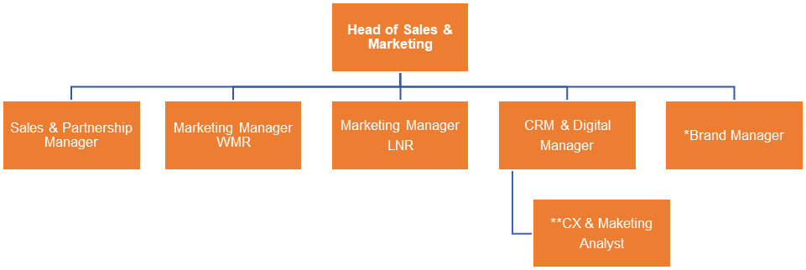
*2 year interim
**Resource in revenue and retail systems

8. | Authority
Authorised By:
Departmental Director:
Date:
I acknowledge receipt of this job description and I confirm that I am fully conversant with its content
Post Holders Name:
Post Holders Signature:
Date:
9. | Deputising Arrangements (if applicable)
I acknowledge receipt of this job description and I confirm that I am fully conversant with its content
Post Holders Name:
Post Holders Signature:
Date:

