Job Description

Job Holder: CRM & Digital Marketing Manager

Reports to: Head of Sales & Marketing

Grade:

Safety Status: NSC

Date version agreed: Draft Version One

1. Job Purpose

1.1 Own & develop the CRM & digital acquisition strategies to drive E-commerce growth and build customer trust through online channels for the WMR and LNR brands. Build plans to support the WMT business revenue targets and maximise profitable growth of products and services whilst supporting promotion of the WMT marketing franchise commitments.

2. Key Accountabilities

2.1 Lead & deliver CRM, SEO, PPC and digital display (paid & earned) strategies to support business/product objectives and the overall business revenue and growth objectives for WMT brands (West Midlands Railway & London Northwestern Railway).

2.2 Work closely with the marketing team, revenue management, sales, customer experience and retail functions to analyse current sales/market performance of online channels and develop campaigns to deliver E-commerce objectives and build trust in our brands amongst leisure & business customers and commuters.

2.3 Responsible for concept, delivery and analysis, including idea generation, proposal preparation, overseeing production process and overseeing execution.

2.4 Establish ongoing reporting dashboards to provide customer behaviour and actionable insights to drive E-commerce growth and build trust amongst online customers through digital channels.

2.5 Evaluate online performance of tactical campaigns, sharing insights with internal teams and approved agencies for future development and optimisation.

2.6 CRM: proactively build trust with known customers by creating a customer focussed approach to improve customer issues and challenges. Build awareness of the products available now and the investment initiatives to come. Deliver positive customer satisfaction, reduce churn rate and increase retention in this channel.

2.7 PPC & SEO: responsible for all search engine marketing and search engine optimisation to achieve the highest possible ROI and drive customer acquisition. Launch & optimise various PPC campaigns overseeing accounts on search platforms. Brief agencies for keyword selection, audience targeting, and bid management. Develop and track KPIs to assess performance and pinpoint issues. Write attractive and concise copy for adverts.

2.8 CRO/CJO: working with digital channel owner to develop a conversion rate / conversion journey optimisation strategy to improve ‘look-to-book’ of warm prospects.

2.9 SEO: establish a web presence to boost brand awareness and new product initiatives.

2.10 Keep abreast of PPC, SEO, CRM trends.

2.11 Champion data protection on behalf of marketing, working closely with head of internal audit to ensure all channels are compliant with GDPR.

2.12 Lead digital agency pitches to introduce good value capability into the agency roster. Manage data agency.

2.13 Contribute to the development of marketing propositions to support the new product, route and service initiatives

2.14 Manage and forecast CRM and digital acquisition budget in agreement with head of marketing & sales.

2.15 Support development of the marketing strategy for sales channel and smart ticketing investment and channel switch objectives

2.16 Represent WMTs digital data, acquisition & retention interests at Abellio Group and collaborate for cross-group projects.

3. | Role Dimensions
Financial |  |  | Non-Financial
WMT digital budget – circa £1m |  |  | Understanding of all elements and best practice of digital acquisition and retention.
WMT revenue targets £460m |  |  | Proactively manage self-development and being a positive voice for WMT digital amongst inside and outside of the industry.
 |  |  | Represent WMT at Abellio Group for digital collaboration.
4. | Main Contacts (External/Internal) *
Contacts |  | Frequency |  | Purpose
WMT Head of Sales & Marketing |  | Daily, weekly, monthly |  | Objectives and plans briefing and activity progress and result reports.
WMT marketing team |  | Daily, weekly, monthly |  | Collaboration & briefing activity plans, measurements and results.
WMT Head of Internal Audit |  | As required |  | Data protection
WMT Market Analyst (revenue) and Customer Insights Manager (customer experience) |  | Daily, weekly, monthly |  | Establish reporting & measurement metrics ongoing sharing of information to inform activity.
Suppliers: creative, data, digital, media |  | Daily, weekly, monthly |  | Buying, planning, briefing, production and measuring effectiveness.
Abellio Group / sister TOCs |  | As required |  | Share knowledge & collaborate on projects

5. | Experience, Knowledge & Qualifications Required
5.1 | Educated to degree level, ideally with marketing qualifications
5.2 | Minimum 3-year experience in a direct marketing environment including acquisition & retention marketing.
5.3 | Knowledge of SEO, digital marketing concepts, analytics and data visualisation tools.
5.4 | Logical thinker with excellent organisational and project management skills. Proven track record of budget management.
5.5 | Ability to multi-task and deliver under tight deadlines
5.6 | Commercial awareness & financial understanding, delivering digital activity in a competitive environment.
5.7 | Excellent negotiation and communication skills
5.8 | Analytical thinking with strong math skills

7. Organisation Chart

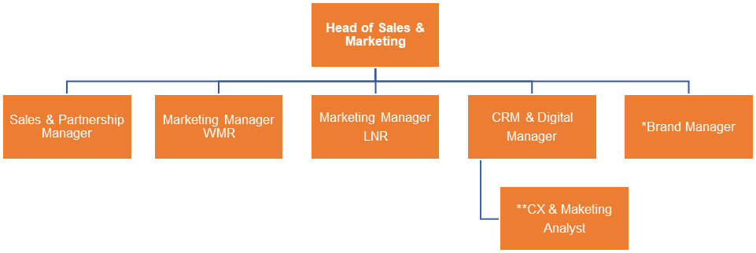
*2 year interim
**Resource in revenue and retail systems

8. | Authority
Authorised By:
Departmental Director:
Date:
I acknowledge receipt of this job description and I confirm that I am fully conversant with its content
Post Holders Name:
Post Holders Signature:
Date:
9. | Deputising Arrangements (if applicable)
I acknowledge receipt of this job description and I confirm that I am fully conversant with its content
Post Holders Name:
Post Holders Signature:
Date:

