Job Holder: Engineering Graduate Trainee

Reports to: Head of Fleet Technical & Performance

Grade: A2

Job Purpose

To undertake a programme of training as part of the ATOC Railway Engineering Graduate Scheme, intended to lead to Chartered Engineer status. The training programme comprises a number of internal and external placements and projects relevant to rail traction and rolling stock engineering, providing a positive contribution to the business, and is intended to lead into a suitable leadership role within West Midlands Trains Asset Maintenance.

Safety Details

The job holder is required to hold a relevant Track Safety competence (e.g. PTS).

Key Accountabilities

- Undertake programme of training in accordance with ATOC Railway Engineering Graduate Scheme.
- Register on the IMechE eMPDS scheme and produce reports and provide evidence to keep the scheme up to date.
- Regularly carry out reviews and competence assessments with Professional Engineering Mentor and ATOC REG Scheme Administrator in order to increase competences required.
- Undertake internal and external placements in accordance with the Scheme, gaining knowledge and acquiring competences.
- Undertake projects during placements which bring benefits to West Midlands Trains as well as contributing to increased competence.
- Contribute ideas and suggest improvements to line management during placements, using and developing technical and interpersonal skills.

Context

A: Operating Environment:

West Midlands Trains operates a large fleet of rail vehicles which must be maintained and fit for use. All elements of vehicle design, specification, procurement, operational and engineering safety and risk based maintenance regimes, are relevant and require the involvement of Engineers. In addition, West Midlands Trains, as a train operating company, must ensure compliance with ROGS, RIR and other applicable legislation and standards as detailed within its Safety Certification to ensure safe operation of rail vehicles on the national rail network.

B: Framework and Boundaries:

The role involves training placements at a number of locations and within a number of departments and organisations. This requires compliance with local safety systems and procedures at all times, under guidance from local management.
Relationships

A: Reporting lines

This role reports to the Head of Fleet Technical & Performance.

B: Other Contacts:

- Predominantly through the Asset Maintenance department, but also with other departments to increase awareness.

Outside the Company:

- As agreed within the training scheme.

Knowledge and Experience

- Graduate Engineer with a MEng or BEng degree accredited by the IMechE or IET.
- Broad interest in engineering aspects of rail vehicles and their operation and maintenance.

Job Challenge(s):

- The job holder will need to be well organised and motivated to meet deadlines and ensure timely submission of required reporting on the eMPDS system.
- The job holder will need strong interpersonal skills in order to gain maximum benefit from relatively short placements both internal and external to West Midlands Trains. Active engagement with a wide variety of people is essential.
- The job holder will need to be able to digest and interpret large amounts of new information in order to develop the required competences.

10. Sign off

Job Holder:……………………………………………….. Date:………………..

Manager:………………………………………………….. Date:………………..
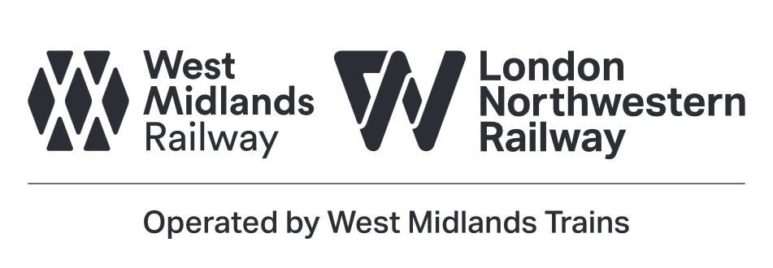
Nominated Deputies

If this is a KEY SAFETY POST (See section 2) a Nominated Deputy must be identified. The job holder must ensure that the Nominated Deputy receives a copy of, and is briefed on, this Job Description.

Job title of
Nominated Deputy: ……………………………………………………………....

Name of
Nominated Deputy: ……………………………………………………………….

Signature of
Nominated Deputy: ……………………………………………………………….

Date: ………………………………………………………………………………….

As the Nominated Deputy for this post, I confirm that I have been briefed on the requirements of this job. If there are more Nominated Deputies they should sign further copies of this Job Description.

