Job Description

Post: Revenue Officer
Reports to: Station Manager
Grade: Revenue Officer
Safety Status: Non-Safety Critical
Date version agreed: April 2014

Job Purpose
To ensure a consistently high level of customer service and revenue protection activity across the London Midland network The purpose of this role is li/ensure that all travelling passengers are in possession of a valid ticket for their journey The post holder will at all times provide an excellent level of customer service. The key measure of success is to change behaviour so that passengers travel with a valid ticket going forward and the company meets its targets in relation to ticketless travel and customer satisfaction.

Key accountabilities
- Ensure compliance with all safety responsibilities, reporting any unusual occurrences and/or unsafe practices in line with company procedures. This would also include alerting station security staff and/or British Transport Police to any anti-social behaviour.

- Undertake full inspection of tickets (including ITSO smartcards and Oyster cards), passes and rail cards at stations, ensuring a high level of customer service at all times, dealing effectively with passengers who are not in possession of a valid ticket. This will include issuing Penalty Fares to those passengers not in possession of a valid ticket without a valid reason, and to issue appropriate tickets to those passengers not liable to a Penalty Fare.

- Operate automatic ticket gates where in place.

- Undertake customer service or crowd control duties at home or other stations, including during special events and disruption. During unplanned disruption to train services you will be expected to keep customers informed to the best of your ability and provide the highest level of customer service possible.

- Provide excellent levels of customer service at all times.
- Report any unexpected ticket office closures, excessive queues for tickets or faulty self-service ticket machines in line with company guidelines.
- Conduct interviews with those suspected of travelling fraudulently under the terms of the Police & Criminal Evidence Act 1984 as it relates to the questioning of suspects. Prepare notes from such interviews and submit travel fraud reports as you may be required to attend court and give evidence in support of cases of fraudulent travel.
- Ensure all ticketing equipment provided to carry out duties is used in a proper manner and that any defects are promptly reported. As ticketing technology develops you will be expected to efficiently operate all ticketing equipment issued to you following appropriate training.
- Wear the agreed uniform to the required standard as provided at all times whilst on duty (including PPE if required).

- Always work within the limits of your own authority and in accordance with all the applicable regulations.

Knowledge, qualifications and experience
- Numeracy and literacy skills to a level equivalent to GCSE grade A-C in Maths and English. NVQ in Customer Service is desirable.
- Understanding of LM operations, ticketing and geography covered
- Experience of working in a customer service and retail environment is desirable, and experience of working in a cash-handling environment is especially advantageous.

- Ability to demonstrate excellent levels of customer service

- Ability to deal effectively with customers, especially those who do not have valid tickets

- Ability to communicate confidently and effective y with all customers and colleagues

- Be willing and able to make effective 'on the spot decisions taking into account all relevant information
Job dimensions

  - Direct staff

  - Indirect staff/ others

  - Financial
The role forms a vital part of the company's approach to minimize ticketless travel across the network. The role involves handling cash and credit/debit card transactions.

Sign off

Job Holder: ……………………………………………….. Date:………………..

Manager: ………………………………………………….. Date:………………..

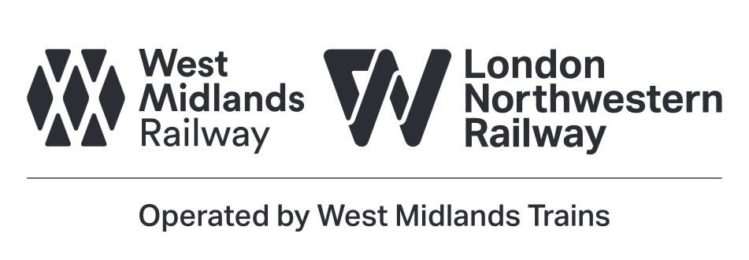
Head of HR ………………………………………………… Date…………………

